**Lynch Conference Room Presentation setup**

**Virtual Computer**

Directions:

* Turn on the TV by pressing Power using the remote.

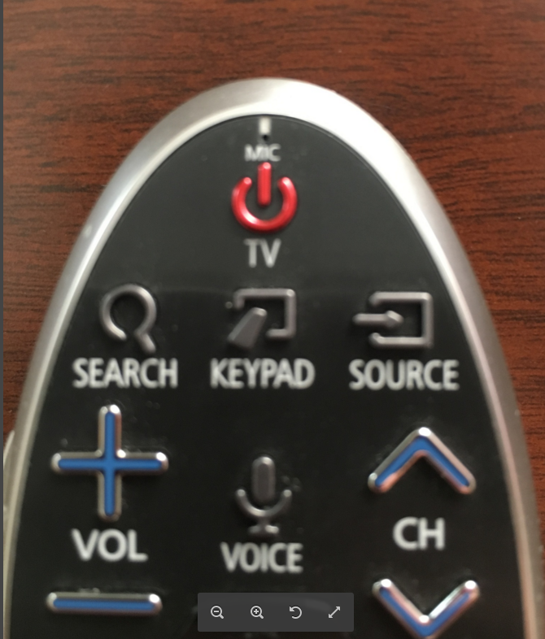

* Press **Source** button until you get to **HDMI 2** on the screen.

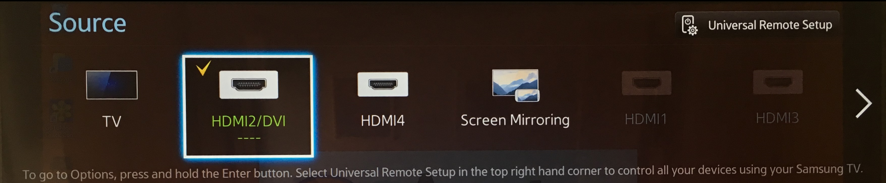

* The virtual computer should be on and showing the desktop or login screen.

Login: **Staff**

PW: **laptop**

* Use the wireless keyboard with touchpad to access the virtual computer.

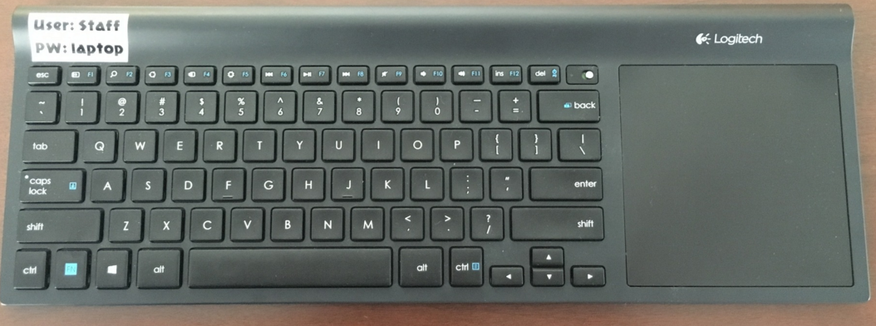

***Important:*** You will have to manually turn on the keyboard. Please switch to off position when you are finished to save battery life.

On Off

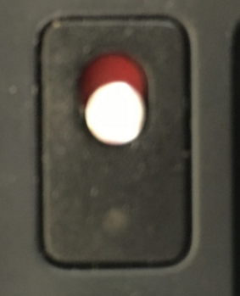

* On the desktop is a file folder named Lynch Presentation

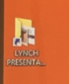

* Double-click on the file folder. This will open up the Lynch Presentation folder under shared workspace. If you uploaded the presentation to Box (**Shared Workspace>Lynch Room**) ahead of time it will be there.
* Double-click on your presentation and it will open in the appropriate software.
* ***Important:*** *Once done, please move/delete your presentation from the Box Lynch folder.*